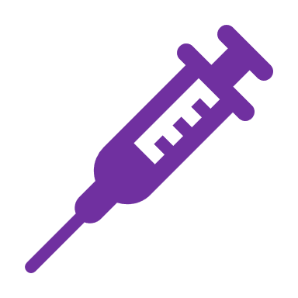
Important update on the coronavirus vaccines and booster jabs:
Vaccination Autumn Booster coming your way soon.
The Joint Committee on Vaccination and Immunisation (JCVI) has approved an additional booster dose this autumn for the most vulnerable people, in order to top up their protection levels to coronavirus. The extra autumn booster dose will be available around three months after the last vaccine/booster dose for:
- adults aged 50 years and over
- people aged 5 years and over who are in a clinical risk group
- frontline health & social care staff

What if I am still due my other vaccinations?

These are still available through your healthcare. Make an application to get yours now.

Is the vaccine safe?
Yes. The UK regulator and the Joint Committee on Vaccination and Immunisation (JCVI) (the independent experts that advise Government on all vaccines) have assessed all approved vaccines to be safe and able to offer a high level of protection against becoming severely unwell with coronavirus, including for older people.

Why do we need booster jabs?
Research has shown that the protection the vaccines provide starts to lessen as time goes on. With a new variant and rising cases, it's important that everyone who is eligible gets their booster.

When will I be offered a booster jab?
Healthcare providers will be contacting you if you are due the next booster. If you are unsure if you are eligible for the autumn booster please contact them and they will be able to confirm.

Do I need to get my flu vaccine too?
Yes, it's important to get both your coronavirus booster and your flu jab. They're different vaccinations that will help protect you against different viruses. It might be that you're offered both at the same time. This is perfectly safe and could be more convenient for you.
What if I have declined previous covid vaccinations?
Healthcare will be able to advise and organise for you to receive the appropriate vaccinations.

