Principles for regime design post National Framework
This briefing provides prisons with principles to consider when operating regimes at the point of exit from the National Framework. Regimes will be developed and operated locally as prisons progress towards a BAU level of delivery and manage enduring backlogs. This document does not intend to provide mandatory actions but give principles for local consideration, enabling each establishment to apply them to meet their business delivery.

Managing and reducing backlogs including training, remains one of four recovery priorities, set for this period and we recognise these will continue to exert pressure.
Prisons must have Regime Management Planning (RMP) system in place as per PSI 17/2017, for the day-to-day management of staff resources and regime delivery, to ensure that regimes are Safe, Decent, Secure, Resilient and Sustainable.
The RMP presentation (see below) provides high-level guidance on the principles of regime management planning. In addition, we are organising five virtual RMP workshops for frontline HMPPS staff in May 2022. Requests to attend the RMP workshops should be made to the FRD functional mailbox at futureregimedesignteam@justice.gov.uk

The Stage 1 model originally issued in July 2021 included a Regime Review Tool which outlined principles for building regimes during recovery. Whilst we recognise that aspects of this model have become less pertinent, the principles included the following which remain relevant:

- Regimes should represent a locally determined balance between safety and sufficiency (judged by the Governor and endorsed by the PGD).
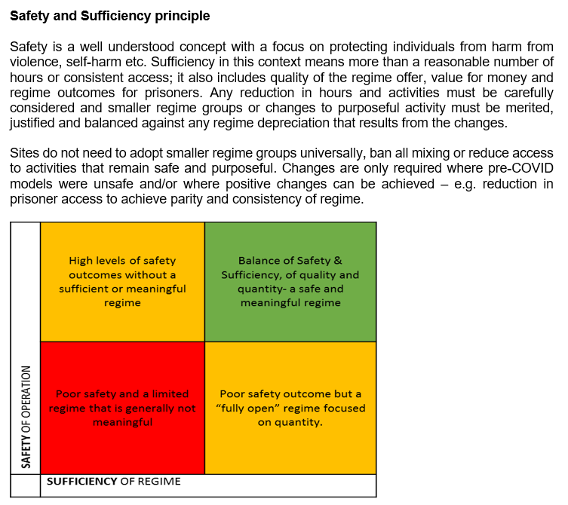
- Access to regimes should be fair, inclusive, and consistent and regimes should attempt to even out pre-COVID disparities in levels of access.
- Establishments set local group sizes and supervision arrangements for each activity and area. All must be covered by risk assessments agreed locally.
- Regimes do not have to change everything from pre-COVID. Where activities, movements and other aspects of regime remain safe and purposeful, supported by reviewed activity risk assessments, these can be maintained.
- Prisons should set a safe level of access to all areas including traditional (tier 1) activity areas such as workshops and do not automatically need to reduce numbers or revert to part-time activity.
- We must safeguard commercial and contractual requirements by maintaining the number of prisoners in contracted activity areas, including those serving the internal market - Critical-prisoner-roles.
- Those prisons able to increase or introduce extra-curricular enrichment activity (tier 2) including structured on wing activity (SOWA) should do so.
- Prisons should consider the needs of complex prisoners, those not engaging or minority groups and ensure every prisoner has access to sufficient tailored purposeful activity to meet their needs.

The focus is on providing a regime that represents a best-effort balance of safety and sufficiency for all that can be sustained and consistently delivered with existing resources. These are principles to support current recovery during the current financial year.

During this period the Future Regime Design (FRD) team will be working with Governors and other design partners including frontline staff to develop a new National Regime Model that will reform regimes in the longer term. Engagement commenced at the Governing Governors Forum (GGF) in May 2022 with valuable input. A design phase will launch to create the National Regime Model, running until January 2023.

In the interim the first two elements of the National Regime Model have been developed and published to signpost establishments to future changes. A new definition of Purposeful Activity has been created together with a Technical Note (see below) explaining its use.
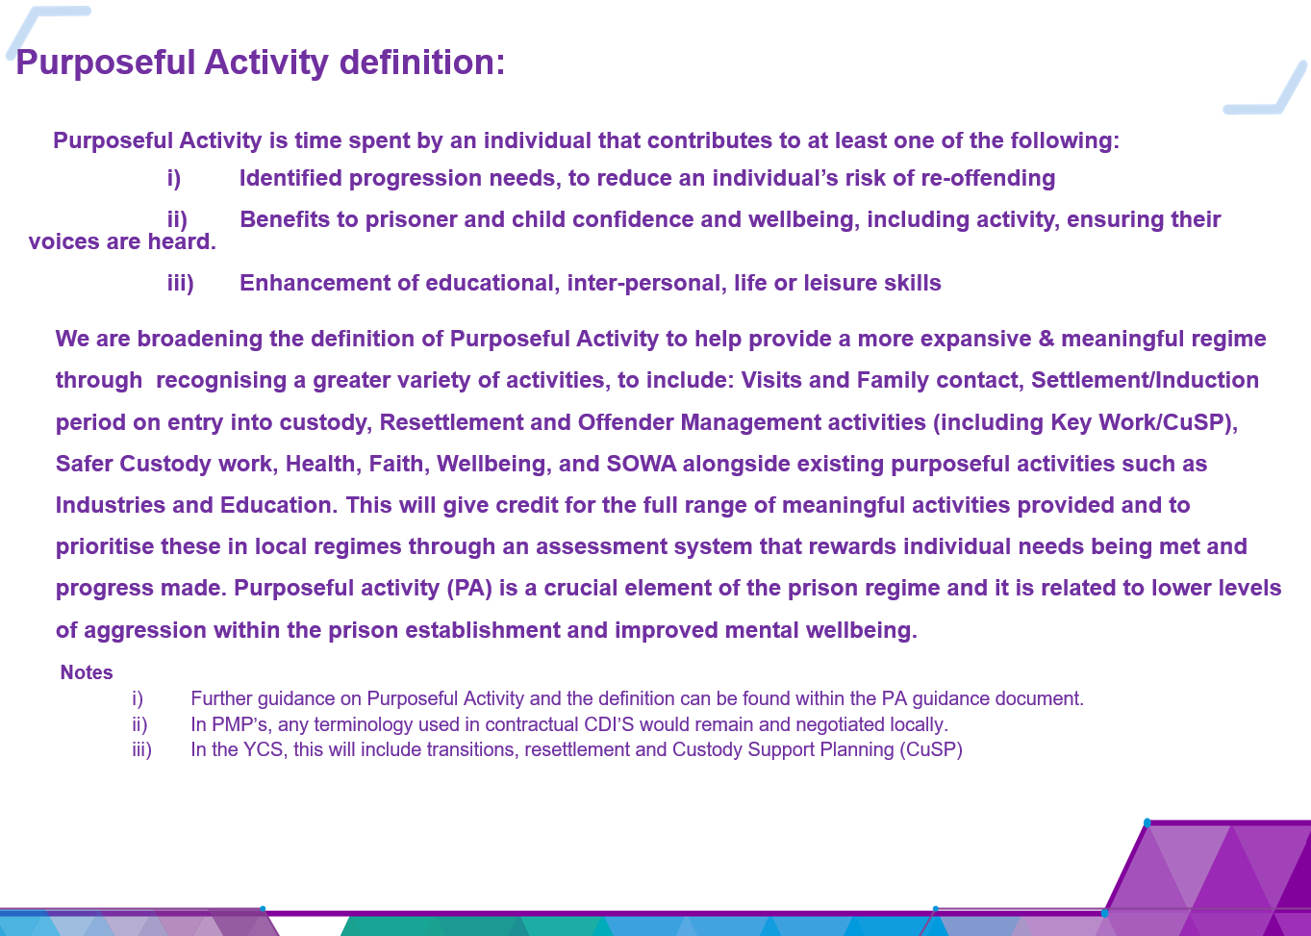
A new Tiered Regime Model template has also been developed. In the longer-term regimes will be developed using this template and contain a locally designed combination of tier 1 (core-curriculum) and tier 2 (extra-curricular) activities to meet local needs and prison function.

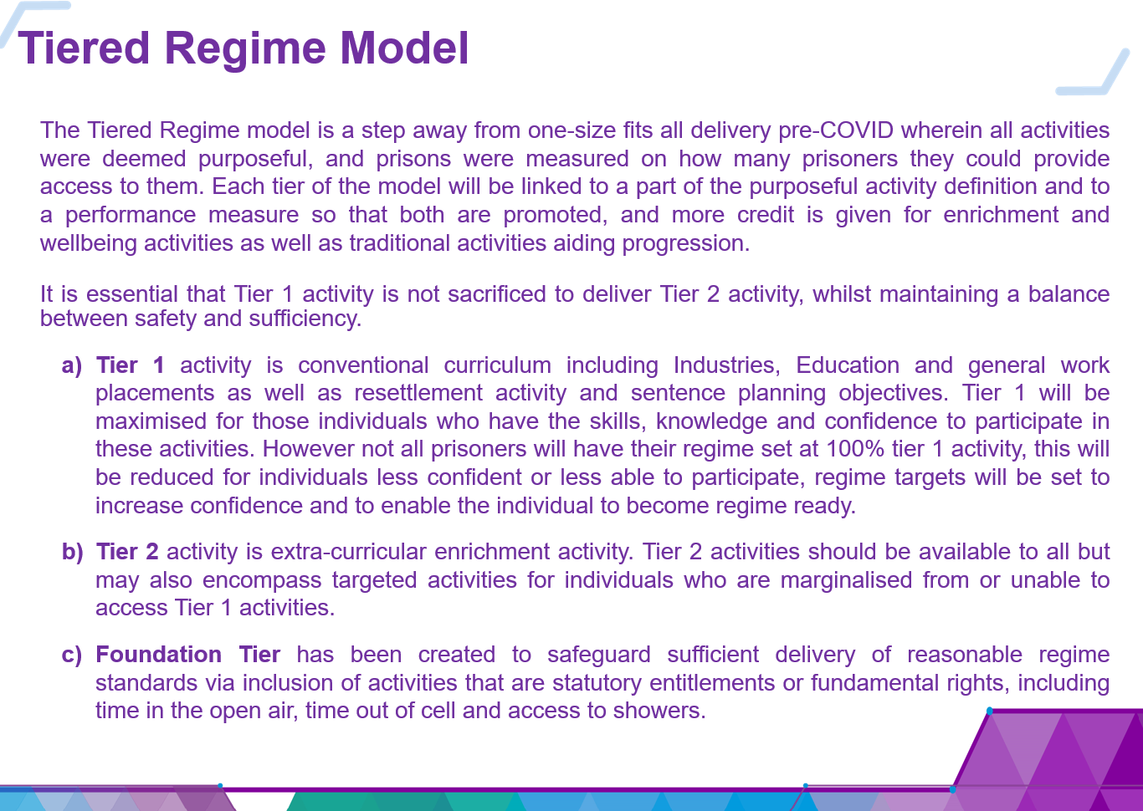
Whilst managing the enduring pressures, prisons that can introduce new tier 2 activities run by staff, prisoners and/or third sector agencies are encouraged to do so. As an enabler to tier 2 activity NOMIS has been enhanced to enable tier 2 activity to be recorded alongside existing and traditional activities. Tier 2 activity is also covered by the new definition of purposeful activity. Guidance has been produced on Recording Purposeful Activity to reflect these changes.

The National Regime Model will eventually deliver the HMPPS “Time Well Spent” vision.
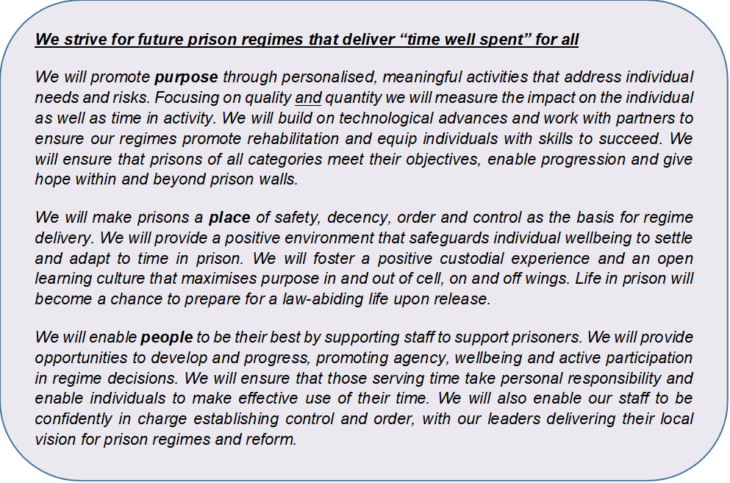

Time well spent means supporting prisons to perform their specific functions efficiently and effectively, maximising resources and using evidence and learning to deliver consistent, safe, decent, secure and rehabilitative regimes. Time well spent also means:

- Every activity matters – all activities contributing to a prisoner's resettlement.
- Right services, right person – individuals receiving the right activities and services at the right time through greater personalisation in regimes rather than success being measured solely by quantity in available activities.
- People, place and purpose – better rehabilitation outcomes include opportunities for staff and prisoners with skills to design and deliver activity for others; people going to the right places to meet their needs and a new definition of purpose.
- Safety, sufficiency, quality and quantity – prison regimes will deliver a balance between accountability and autonomy by providing national products and parameters to guide local regime design whilst safeguarding consistency and delivery against national expectations.

For further information on this briefing please contact the Future Regime Design Team – futureregimedesignteam@justice.gov.uk

RMP Presentation | PA Technical Note

