Amended Routine Testing Requirement for Prisons in England and Wales

Testing remains an important control measure to reduce the risk of introduction and transmission of infection into and between establishments. HMPPS has therefore been undertaking a regular weekly testing rhythm across prisons to protect staff and those in our care. This rhythm will remain the same but will now be mandatory for HMPPS staff. Mandating testing is a temporary measure and our national risk assessment will be subject to fortnightly review. Once that assessment indicates mandatory testing is no longer a reasonable and proportionate measure, it will come to an end.
Omicron cases in the community are currently doubling every two days and the Variant has demonstrated an ability to evade prior protection. Whilst the severity of the Omicron variant remains unknown, the projected high numbers of infections could still lead to significant pressure on hospitals. The heightened risk from Omicron has prompted an urgent review of staff testing in prisons to ensure that the controls remain proportionate to the risk and to support the continued operations of prisons.
Staff Testing
This briefing applies to all prison and probation staff working in prisons who are employed directly by HMPPS in England and Wales. HMPPS are working with partner organisations who have staff working in prisons, with a view to their adoption of the same approach for their staff; at this time, testing remains voluntary for non-directly employed staff.

From midday on 23 December 2021 directly employed staff in prisons will be required to undertake routine testing. The current testing rhythm of 1 PCR and 2 LFDs weekly will be mandatory for the duration of the period of heightened risk.

LFD testing: LFD testing should be completed at an Asymptomatic Testing Site (ATS), and wherever possible, before starting shift. Alternatively, staff could choose to test at home and take a time and date stamped photograph (with a smart phone) of their result. This will be subject to random spot checks by HRLs at the discretion of Governors. (See Assurance)
PCR testing: Staff must also continue to test weekly with PCR.
Please note that this applies to routine testing only and the separate arrangements for Daily Contact Testing (DCT) and Daily Testing of Contacts of Covid (DTCC) will continue in prisons in England. Risk Mitigation Testing (RMT) will continue in prisons in Wales.
Considerations
Staff will have a choice to either:
- test at home using Self Collect prior to attending work, or
- attend the prison ATS to take a test before their shift or as early in the shift as possible
Governors must set up an Asymptomatic Test Site (ATS) where they don’t already have one in place. The current changes to more restricted prison regimes will tend to reduce overall staffing requirements, although Covid-related absences will tend to increase during the current wave; any improved staffing availability may be utilised to achieve the new testing requirement. Governors may wish to consider setting up multiple ATSs within the prison to support the increased capacity for testing. Further detail on training staff to run an ATS and the additional considerations needed can be found in the staff testing manual (linked here)
Prisons will need to review their current stock levels in light of the increased testing requirements and should amend any future orders to reflect this. Where stock levels are running low, they must prioritise testing capacity for operational staff and must contact HMPPSTesting@justice.gov.uk for an emergency order without delay. For orders to arrive by 29th December, they must be placed by 5pm 23rd December.
When conducting their twice weekly LFD tests, staff should, wherever possible, not commence work until a negative LFD test result is provided (between 15-30 minutes from swabbing). At the ATS, a waiting area permitting social distancing should be provided to staff whilst they wait for the result.
It is important that in delivering this level of testing, Governors remain focused on the delivery of a consistent and predictable regime including the unlock for courts and the day’s regime. Payment plus can be used for the task of delivering testing at an ATS (which may be added to work profiles if helpful) or to relieve staff to attend an ATS. Prisons will find their own model based on local circumstances; however, Governors must ensure that they have adequate controls in place.
Prisons should ensure that any probation staff working at the prison have access to tests at the ATS and can also take Self-collect tests home if they wish to do so.
Communications
This briefing will be accompanied by a letter and a poster to support prisons in sharing this update with all staff.
An updated Participation Information Sheet will also be provided to outline the testing process to staff.

HR Advice
Where a member of staff refuses to test, managers should engage with the staff member to ensure that they understand the reason for that reticence, and that the member of staff is fully briefed about the reasons for the requirement, and on the benefits to their colleagues and those they care for and themselves. The implied risks of non-testing and their statutory duty under Health and safety legislation, to co-operate with us as the employer in fulfilling that duty to Health and Safety, should also be highlighted. Managers should consider whether the member of staff has any exceptional reasons for refusal which are reasonable. If someone cannot take a test for medical reasons, they will need to provide written evidence from a medical professional.
The mandatory testing does not require a test before every shift – it is a screening testing programme and will apply to the staff member’s designated testing days for the 2 LFDs and 1 PCR per week. If a staff member does not have any exceptional, reasonable grounds to refuse the test but continues to do so, despite discussion with a manager to explain and make clear the requirement, they must be allowed to work as normal and asked to reflect on the situation, be informed that further discussion and advice remains available to them, and that the requirement to undertake tests remains in place.
Managers will wish to follow up such cases a few days later when the staff member is next scheduled to have a test, to establish whether the staff member has begun complying with the policy.
Managers have discretion to decide how long they will maintain efforts to persuade the member of staff to follow the legitimate management instruction to undertake the required testing, in light of the nature of the discussions with the staff member.
Where the refusal is maintained, this apparent misconduct must be addressed under the Conduct and Discipline Policy PSI 2010-06 - HMPPS Intranet (gsi.gov.uk).

Assurance
If home testing is the chosen method of delivery, staff will be asked to take a time and date stamped photograph (most smart phones do this automatically) of their result after each test. Staff should email the photos to their work email accounts once taken so that they have these on hand when required for assurance checks. Staff should ensure there is no cost to them when doing so.
Prisons should conduct sample checks of this evidence on a weekly basis to gain assurance that home testing is being conducted as reported. The below photo demonstrates that the file information of a photo received by email will confirm the time and date a photograph was taken. These assurance checks should be managed locally and there is no national request for this data currently.
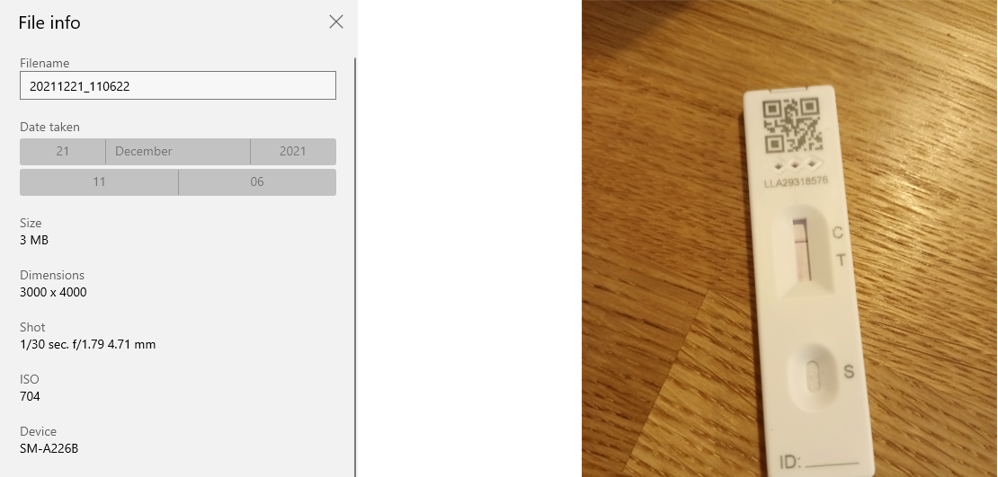
If staff do not have the means to take or share photographs of their tests, they can opt to test at the ATS.

Additional Information
The below table provides an overview of the testing programmes available and confirms their required frequency.
If there are any queries, please contact HMPPSTesting@justice.gov.uk

Testing Regime | Frequency / Timing | Type of Test
Routine PCR Testing | Weekly – either at home or on site | PCR
Routine LFD Testing  OR  Routine Self- Collect testing | Twice weekly testing at prison Asymptomatic Test Site (ATS)  OR  Twice weekly testing using Self Collect LFD tests. To be completed at home prior to attending work (in place of attending the ATS) and a time and date stamped photograph must be taken. | LFD
Daily Contact Testing (DCT)  England only | Testing through a 7-day period. Testing daily during isolation period for staff who are not fully vaccinated and who have been in contact with a positive case. DCT enables them to return to work each day (subject to eligibility requirements)  This is separate to the routine daily testing requirement as this is an additional mitigation in supporting staff to return to work.  DCT MUST take place at the dedicated separate DCT prison ATS before attending work. | PCR  LFD testing at separate ATS
Daily Testing of Contacts of Covid (DTCC)  England only | 7 days daily testing. Testing to enable staff who are fully vaccinated and who have been in contact with a positive case to return to work as an additional safeguard.  This is separate to the routine daily testing requirement as this is a standalone testing programme in line with the community provision.  DTCC MUST take place in the member of staff’s home before attending work and not at the prison ATS. Tests on rest days are required. | PCR  LFD
Risk Mitigation Testing (RMT) Wales only | 7 days daily testing. Testing to enable staff who are fully vaccinated and who have been in contact with a positive case to return to work as an additional safeguard.  Staff must take a PCR and isolate until the result is known before RMT can commence. | PCR  LFD

