Simple Workout Guides
Warm up:
Do each move for 20 seconds. Do this warm-up twice.
- Jumping jack
- Inchworm walk out to shoulder tap
- Squat
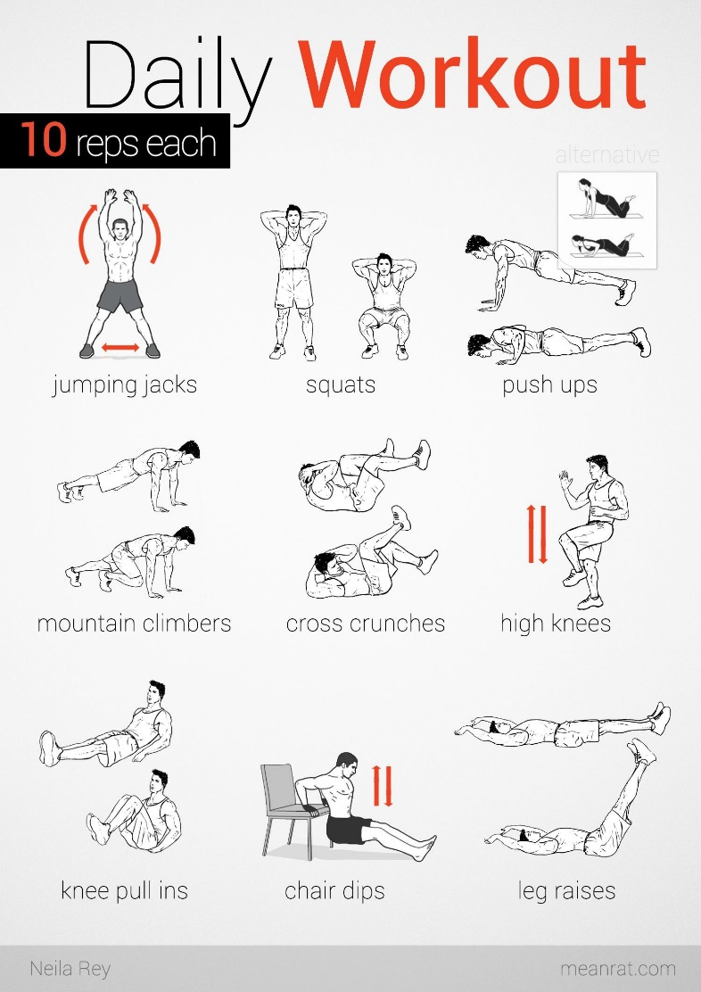
Circuit 1:
Three reps of each:
- 10 body-weight squats
- 10 push-ups
- 10 superman
- 20 crunches
Circuit 2:
Three reps of each:
- 10 walking lunges
- 15 seconds plank
- 30 jumping jacks
- 10 side leg swings

Circuit 3:

Three reps of each:

- 10 mountain climbers
- 10 cross crunches
- 10 leg raises
- 10 high knees
Cool down

- Forward fold
- Side bends
- Shoulder rolls
- Hamstring stretch
- Quad stretch

