Building self-care routines into your day can help you feel well, both physically and mentally. Self-care means different things to different people, and we will be exploring different activities for you to try out. Remember, as with everything, self-care takes practice!
In the next few distraction packs, we will be sending you information about different self-care activities to try. Make a note of which ones you find most useful, and try and build them into your routine.
Self-care: the face
Face facts
The face has the biggest range of muscles in the body, and 43 of these muscles are linked to facial emotions. We are capable of making over 10,000 unique facial expressions. However, a famous study from the 1960’s found that all cultures associate these 7 facial expressions with the same seven emotions. Can you identify them all? (Answers at the bottom)

The masseter muscle (that we chew with) is the strongest muscle in the body. It is capable of pulling up to 80 times its own weight!
With all these muscles at work in our face, how often do we stop to take care of them? Feelings of stress of anxiety can cause us to clench our jaw and hold tension there.
Paying attention to your face each day may not only help you to relax, but amazingly, your facial expression can actually change your mood. Studies have shown that smiling can make you feel happier, frowning makes you sadder, and showing no emotions can make your emotions less intense.

Answers: disgust, anger, fear, sadness, happiness, surprise, contempt

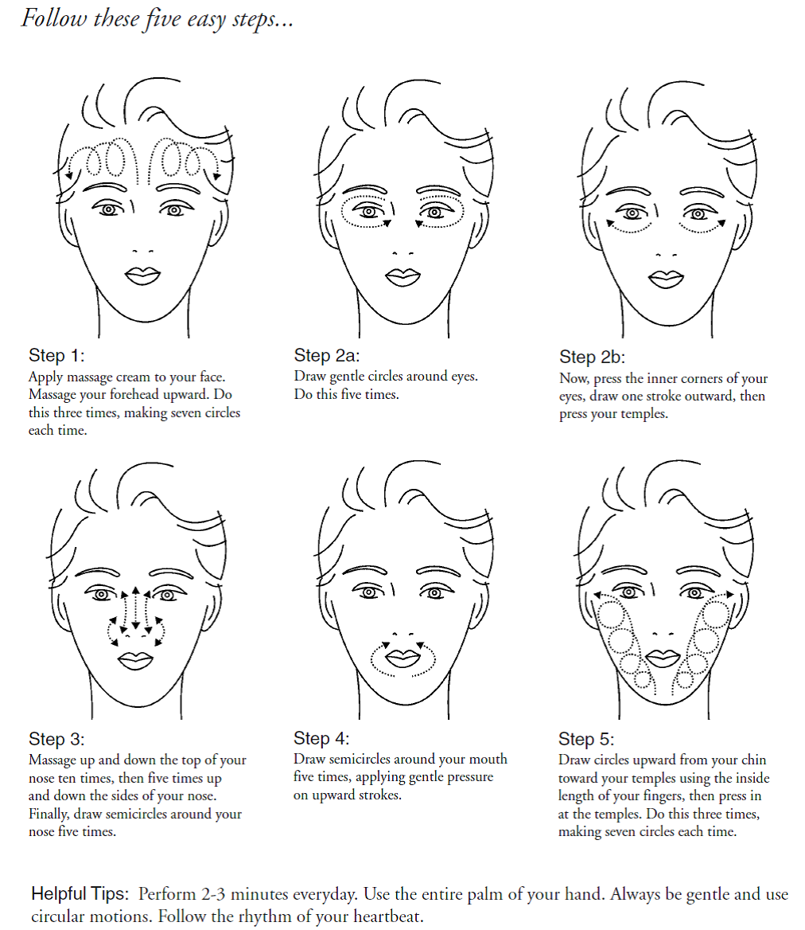
Try this facial massage routine. Wash your face and hands before you start. You can use face cream to moisturise, or it works just as well without any!

Remember that even the simplest routine to look after your skin can help you feel fresh and improve your self-confidence.
It can be hard in prison with less access to showers, but you could still try and think about the following things:
- Face wash/soap – do you use soap to wash your face in the mornings or evenings? Using soap can make your skin more dry, which can lead to skin problems. If you like using soap, try using it only once a day.

- Moisturiser – You can use body moisturiser or cream on your face. If you have very dry or oily skin, it may be worth trying to get a specific type of moisturiser.

- Towel - Remember to use a clean towel! You don’t want to wash all the dirt off your face, and rub it back on again with a dirty towel!

- Routine – aim to give your face a wash in the morning and the evening (with soap once a day). Combine it with your other routines, like brushing your teeth or before you have a cup of coffee

- Water - The kindest thing you can do to take care of your skin is make sure you are drinking enough water! 8 glasses a day are recommended

Acne
Acne is a very common condition that causes spots. It occurs when tiny holes in the skin, called skin follicles, become blocked. 85% of people aged 18-30 have acne, but it can affect you at any age. If you do have a spot, try not to squeeze it as it can aggravate the area, spread bacteria and lead to scarring. Keep washing your face twice a day (don’t over wash).

Building self-care into your routine

One fact about the face that surprised me:

How did you feel after you tried the facial massage? Did you feel the same? More relaxed?

Is this something you would like to build into your daily routine? If so, when?
- Once a day
- Twice a day
- When I am feeling stressed or anxious
- Before bed

After reading about skincare routines, are there changes you would like to make? Tick a goal, and see if you can practice it every day for a week. Tick off each day when you have done it as a reminder.
Wash my face twice a day using water in the morning and soap in the evening Moisturise once a day
Drink 8 glasses of water a day

Monday | Tuesday | Wednesday | Thursday | Friday | Saturday | Sunday

Do you notice a difference at the end of the week? Did you find a time of day it was best to do it on?

