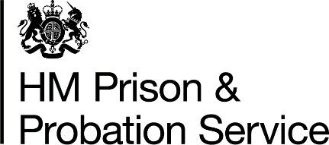
Prisoner Wellbeing Fund Record
Please use this form to record the details of the items that have been ordered to improve prisoner wellbeing over Christmas and into the New Year. You should include your current population and the corresponding value of the fund.

There is no approvals process for this spend and the items are to be purchased as an approved overspend. Completed forms must be emailed to centralFBP@justice.gov.uk and copied (cc) to SaferCustodyPolicyandLearning@justice.gov.uk. You should also keep your own local records.

The wellbeing fund is only available for the rest of this financial year. Items must be ordered, received, and receipted by 31 March 2022, otherwise they will be funded from your baseline 2022-23 budget.

Private Prisons: please use your Prisoner Amenity Fund where applicable. If that is not available, please raise with your Controller or Senior Contract Manager if you wish to implement this fund.

STCs: please speak to your Senior Contract Manager if you wish to implement this fund.

Establishment name: | Name of person completing form: | Role/email address:
Current Population: | Corresponding Value of Fund:
Options for Consideration (not exhaustive) | Indicate details of purchases: | Cost of purchases:
Purchase of materials to support wellbeing such as sleep masks, water bottles, blankets etc.
Increase access to outdoor activities/ PE.
Increase activities for those most vulnerable and/or at heightened risk e.g., prisoners with learning disabilities or older prisoners, prisoners from BAME backgrounds, foreign nationals
Targeting resources towards those environments or cohorts where you are seeing highest levels of self-harm.
Increasing activities available in rooms – weekly craft packs or development of hobbies which can be taken forward in room.
Increase synchronised activities e.g., quizzes, gym activities etc.

Please detail any good practice/ additional interventions you have already put in place in simple bullet points below:

