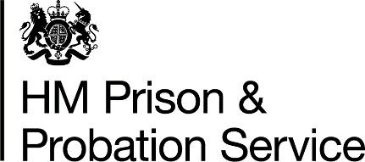
Prisoner Wellbeing Fund FAQ

Question: How long do we need to wait until we are given the go ahead to purchase the items?
Answer: There is no approval process, you can go ahead immediately to purchase the items.

Question: What is the budget code for the central fund so we can use it, we do not have the funds in our budget to pay for these items?
Answer: A budget is not being allocated for this centrally nor will costs be charged to the centre. Each establishment should purchase the items and it will be an allowable overspend.

Question: Some items may not be receipted before 31 March 2022; can we still add them to the form and purchase them?
Answer: No, any item that is not ordered, received, and receipted by 31 March 2022 will be funded from your baseline 2022-23 budget.

Question: Do we order the items and charge back to a central fund?
Answer: The orders are not being recharged to the centre – it will be accounted for through individual prison cost centres, effectively as an allowable overspend.

Question: Should our establishment accrue for these items locally?
Answer: No, establishments should not accrue locally. The Wellbeing fund is being accrued centrally based on the submissions to the CentralFBP mailbox, on the assumption that purchases are being made by GPC.

