Gold Brief – Stage 1 Model, Mechanics for Progression and SOP (published 29.07.21)
Purpose
Since the Stage 2 Gateway was opened in May, we have seen a gradual progression of sites to Stage 2 of the framework, with over 30 sites now delivering Stage 2 regimes and numerous others planning for how they can safely progress in the coming weeks.
The purpose of this briefing is to share the Stage 1 model, the progression mechanics and supporting SOP ahead of the Gateway opening so that establishments can commence local planning and preparation. This has been agreed by the Minister and consulted nationally, including recognised Trade Unions.
This briefing does not signal the opening of the Stage 1 Gateway, which currently remains closed. However, we anticipate that the Ministerial approval to open the gateway will be announced shortly and we will clearly communicate this from the centre.
This briefing has 3 key sections:
- Stage 1 Model
- Mechanics for Stage 1 Progression
- Stage 1 SOP

Additionally, please find 4 Annexes attached at the end of this document- first two (Annex A and B) must be reviewed and completed as part of the progression but Annex C and D are for guidance only and are being shared as they may assist in any local planning. Further supporting materials are also provided on the Operational Guidance Platform.
- Stage 1 model

Stage 1 is the last point of the national framework governing COVID-19 recovery in prisons and the young peoples’ secure estate (collectively referred to in this document as ‘sites’). The COVID threat will remain for a considerable period and it is conceivable that sites may need to return to Stage 2 or beyond during a significant outbreak. However, by retaining a baseline level of COVID controls at Stage 1 as part of the model, sites will have a COVID resilient approach and will not automatically have to return to previous Stages in the event of an outbreak.

Stage 1 is defined as a regime state developed locally by the site that delivers a safe, meaningful and decent regime providing fair and consistent access to a fuller range of activities than was possible at earlier stages of the national framework. A Stage 1 regime will deliver the best-possible local balance between safety and sufficiency of regime as a foundation for the further regime reform that will follow or as a continuation of ongoing reforms in the YCS.
Development of the Stage 1 Model has been a significant exercise in collaboration with a series of engagement events held with many colleagues, including operational representatives at every level, in every role and at every type of establishment.

The Stage 1 model is provided below together with the introduction. Please note that the documents and information provided, including the “Red Flags” will be reviewed and further developed where needed.
- Mechanics for Stage 1 Progression

Prison Recovery Board and POMC have now agreed a progression mechanism for Prison progression to Stage 1 regimes. The agreed progression mechanism is intended to strike a balance between providing sufficient assurance and minimising administrative requirements for progression. The agreed process builds on equivalent arrangements at earlier stages which we hope will limit the administrative requirements at all levels. The below diagram outlines the key steps for progression.

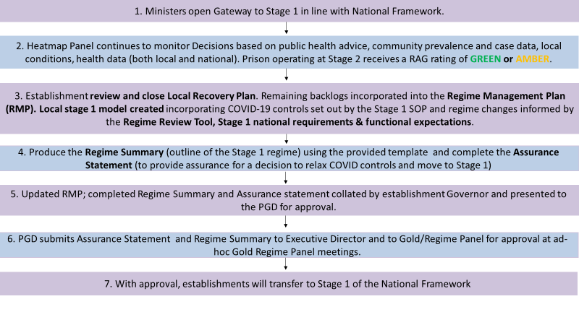

Once the Gateway has been opened, prisons with a Green or Amber RAG rating from the Heatmap panel will be able to begin the process of progressing to Stage 1. This includes the local utilisation of the following documentation.

As part of the process for progression to Stage 2, each establishment has been required to produce a ‘Local Recovery Plan’ (LRP) which contains an assessment of the local backlogs that require addressing and a strategy for delivering a consistent regime while addressing some of these backlog areas. When preparing for transition to Stage 1, establishments will be required to review and close the LRP. It is not expected that all backlogs from the Recovery Plan will have been completed, but establishments should combine these backlogs and any outstanding targets or aims into their Regime Management Plan (RMP)
The Regime Review Tool is an information source providing prisons with principles and considerations when designing Stage 1 incorporating COVID learning points. These national principles must be taken into consideration when making local operational decisions.

Governors should then complete the Regime Summary (Annex B) to outline their planned Stage 1 regimes, including any changes compared to pre-COVID as well as the Assurance Statement (Annex B). This is a formalised statement which builds on the Readiness Assessment Checklist required at Stage 2. The Assurance Statement also contains an ‘Assurance and Risk Framework’ Annex which establishments must complete to identify those areas of recovery they consider to be most at risk, and the mitigations in place to manage them. These will give assurance to PGDs and Gold that lessons have been learned at establishments during Stage 2 on areas of risk and provide the opportunity for some estate wide analysis of patterns of risks and issues.

The updated RMP, completed Assurance Statement, Regime Summary, and any relevant supporting documents must be submitted to the PGD for approval. The PGD will then submit Assurance Statement to the Executive Director and Gold for oversight and verification. The Regime Summary will also be shared for monitoring purposes.

Please note that whilst Privately Managed Prisons (PMP) do not operate under RMPs, the principles of the Mechanics for Stage 1 progression still apply to Private Estate. Thus, rather than building backlogs of recovery work into RMPs they should be recorded as part of contracts for delivery. PMP Stage 1 delivery Plans should be signed off by the Head of Custodial Contracts Group before sending to Gold.

Consultation Requirements
Throughout the National Framework, consultation with our recognised Trade Unions and Health partners alike has been critically important. This requirement for thorough consultation remains at Stage 1 (as in business as usual situations) and establishments will be required to work with local trade unions representatives (or regional representatives (national in respect of PGA and some NTUS reps) where local representatives aren’t available) to determine plans. The existing exceptional COVID recovery minimum 5 working days consultation period (to be aware most NTUS reps do not work weekends) will continue on the basis that sufficient additional local facility time will be provided to local representatives (national reps will also continue on the additional time provided for this period).

Where local circumstances dictate that additional time is required to complete formal consultation, Governors and representative should work together to agree a local timeframe. For example, if the scale of review at Stage 1 makes it necessary for the representative to visit the site (where regional representatives apply), or the representative is unable to complete the consultation within 5 days, it is expected that establishments come to a local agreement with the representative. Establishments are required to consult with Trade Union representatives as early in planning as possible and to ensure that there continues to be full engagement on local risk assessments and safe systems of work. It is expected that representatives will be engaged throughout the planning process, and that the 5 days is the formal final sign off period. The HMPPS Health Liaison team will be working with Public Health Partners nationally to design guidance for their regional system on engagement expectations/considerations to ensure effective consultation.

Regime Regression
The cautious and risk assessed process around recovery to date means that it is envisioned that progression into Stage 1 will likely extend into the autumn/winter period for much of the estate. A prompt response to any new cases remains the appropriate approach, but this will not mean an automatic reversion to more restricted regimes where cases are reported. Where we are confidently able to manage case risk with the controls in place at Stage 1, we will endeavour to do this.

We must however remain aware to the possibility of sites having to re-introduce restrictions to regimes following progression to Stage 1. Progression to Stage 1 is reversible and existing mechanisms for regime regression will continue to be operated where required and will be fully controlled by the Governor with PGD oversight and Gold approval. Where it is necessary to regress regimes, we will maintain the ability to do this. HMPPS will also continue to operate system wide surveillance of all reported communicable diseases in establishments. This may lead again to further national intervention if the risk picture nationally requires an estate-wide approach.

- Stage 1 SOP

The Stage 1 SOP has been designed to communicate the new baseline set of COVID control measures establishments must maintain at Stage 1.
Though the controls in place in prisons are considered separately to those in the community, the SOP has been reviewed and updated following GOV.UK published guidance on 12 July & 19 July for the UK Government Step 4 roadmap measures. The Stage 1 SOP also includes differential details and timings in Wales.
The SOP framework formalises three core elements and the mechanics for this application:
- ‘Baseline’ Prevention – A suite of baseline measures, required at Stage 1, that serve as a first layer of defence against incursion and rapid growth of transmission.
- Surveillance and Detection Measures– Measures to be employed at Stage 1 to provide ongoing detection, monitoring capability and early warning to support further intervention.
- Response Interventions – Further interventions that can be stood up quickly, where necessary, in the event of significantly increased risk or when in outbreak, guided where appropriate by the OCT and heatmap panel RAG rating.

The baseline prevention measure will retain a set of COVID controls being applied at all prisons and sites, whereas the remaining two measures will be applied locally as and when required. The SOP outlines the circumstances and triggers for any potential escalation from the baseline measure. As such, other than within a baseline condition, prisons will be provided with flexibility and autonomy to manage COVID threats locally. This position provides alignment with a UK forecasted situation where the risk of COVID severity is greatly reduced from the vaccination/population immunity with testing and surveillance outcomes in place.
Sites will therefore be able to provide a full set of regimes utilising the Stage 1 SOP, with a reduced but safe set of layered COVID measures commensurate to the local situation. Controls will be applied relating to the local COVID threat. Given the uncertainty of COVID, a full range of our existing controls remain available for deployment where a situation may arise. This provision allows both local and regional response to be triggered without the requirement for central/national regression measures being activated. As such, local flexibility will provide a swift response in getting ahead of threats where required.

Annexes
In addition to the information provided above, attached to this brief is a package of documentation to support you in planning and preparing for Stage 1 progression when the time is right for the establishment.
Attached are:
These must be reviewed and  completed when planning for Stage 1 | Annex A:  Stage 1 Regime Summary Form  Annex B:  Stage 1 Assurance Statement
Key additional materials  (for guidance only) | Annex C:  ‘Benefits mapping’ (comparing pre-COVID regimes to Stage 1 proposals at selected sites)  Annex D:  Case study: Stage 1 regime proposal: HMP  Leeds, July 2021

If you have difficulty accessing any of the documents, please visit the COVID operational guidance platform. For further materials to support you in Stage 1 planning please visit: https://hmppsintranet.org.uk/ersd-guidance/stage-1/
Any queries on this briefing should be directed to: COVID19.RegimesOpsGuidance1@justice.gov.uk

