HMPPS Prison Gold Command Learning Briefing
004/21: Infection Prevention and Control
June 2021

Infection Control Procedures (IPC) are a critical mechanism to prevent the spread of infection within criminal justice settings. Since the COVID-19 pandemic was declared in 2020, Infection Control Procedures (IPC) have become a fundamental tool in justice settings to reduce the risk of transmission of the virus, and protect prisoners, staff and visitors. An independent review of IPCs in prisons has been conducted to investigate the adhere with Infection prevention and controls measures during the pandemic. Its purpose is to learn from experience and share learning, focused on:  - Good practice identified during the inspection process.  - Identify common themes or areas for improvement.  - Identify emerging themes or areas which require attention.  - Provide Recommendations.  We have recently received ministerial approval to open the gateway to Stage 2. As we prepare to reduce restrictions on prison regimes and expand our delivery, it is more important than ever before that IPCs remain at the centre of our work to ensure that we keep our staff and those in our care best protected from COVID-19.  The purpose of this learning briefing is to present the key learning points of the review in an accessible way to the frontline. There are no required actions set out within the briefing, but establishments are advised to consider the key learning in the management of their own Infection Control Procedures. The intended audience is anyone with an interest with IPCs in the operational setting, but establishments may wish to ensure this document is shared with the person responsible for IPCs locally. | Helpful Links  COVID-19 Cleaning Guidelines  COVID-19 Safe Operating Procedures  COVID-19 PPE Guidance  Any Questions?  HMPPS Covid-19 Regime Management Team

General Management
Learning from the Estate:

Recommendations: | 1 | Nominate an individual/small group of individuals to be responsible for IPC locally. Ensure that they are available to contact during operational hours or can reply to queries within a reasonable timeframe.
 | 2 | Ensure that visual reminders such as signage are up to date and that the messages they carry are explained and reinforced to ensure that they are not left to individual interpretation. Signs should be regularly updated to ensure that messaging stays current. Consideration should be given to the location of key signage (focused on prominent areas subject to heavy traffic), and content should focus on key themes:  - Hands, Face and Space  - Donning and doffing of PPE  - Hand hygiene and procedure  - Social distancing / avoid physical contact where possible  - Face coverings and masks must be worn where directed for use.  - Recognise the signs
 | 3 | Ensure that local and national IPC policies (including basic guidance to staff) are available in all work areas (not just clinical areas). Ensure that all staff are aware of where they can access IPC guidance, including guidance on PPE, cleaning requirements and cleaning schedules.

Ensure that trays used to pass staff and visitor items through metal detectors and scanners are cleaning and allowed to dry between each use.

Remind staff of the need to wear PPE via email and the radio.

Locate cleaning materials such as wipes and hand sanitiser in areas of high contact such as near Trakka cabinets. Provide clear signage for staff to utilise in which ever system.

Hand Hygiene
Findings:  - Hand Hygiene was focused on in in all reviewed inspections.  - Whilst evidence suggested that most staff understand the rationale behind good hand hygiene, it continues to be an area where improvement is needed. 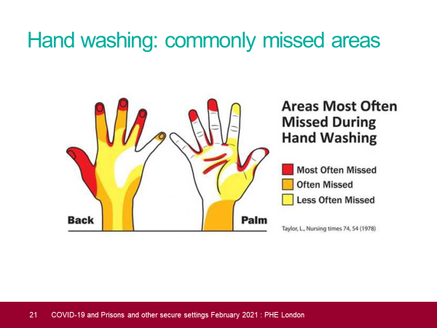  - Access to hand washing supplies (liquid soap, paper towels, hand sanitisers, foot -operated waste bins) was reported as a problem in many reviewed inspections. Supplies were often sporadically located around establishments and there were often limited instructions on use.  Additional Resources:  WHO Hand Hygiene- How, Why and When brochure. | Recommendations: | 1 | Ensure greater focus on handwashing in key hotspots:  - After opening and closing doors / cell doors / gates  - Between the use of office equipment – computers, telephones, sharing of stationery items  - Before, during and after food preparation  - After blowing your nose, sneezing, coughing or touching your mask.  - Touching of other items associated with the work area, including surfaces.  - As specified within the National COVID SOPs
 |  | 2 | Provide clear guidance to all staff and prisoners on the recommended techniques for handwashing. Where possible, the below instructions should be printed and made available in handwashing areas.
 |  | 3 | Ensure continuity in the supply of handwashing materials. Hygiene products will continue to be supplied via the PPE Hubs, sites should continue to place orders in the usual way.

General Cleaning
Why is cleaning important?  Cleaning is a baseline IPC measure which is critical to preventing the transmission of infection. This is even more important within a closed environment like a prison. We know that COVID-19 can spread from person to person through small droplets, aerosols and through direct contact. Surfaces and belongings can also be contaminated with COVID-19 when people with the infection cough or sneeze or touch them.  Increased frequency of cleaning and disinfecting of general room surfaces reduces the presence of the virus and the risk of contact.  It is important that as we move into the recovery period, standards of cleaning do not fall and that all staff and prisoners are reminded of the need to maintain high standards of cleaning in line with agreed SOPs and guidance to ensure that the transmission of the virus is reduced as regimes open up. This will need to continue beyond the pandemic period as IPCs such as cleaning will continue to be our best defence against other viruses and infectious diseases.  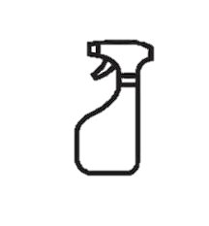 | Recommendations: | 1 | Develop understanding about the importance of cleaning and encourage a proactive culture rather than a reactive one. Sites should aim for a culture that is motivated to ensure all areas are cleaned to a high standard as a daily norm. This will require staff, prisoners and managers working together with the single aim of providing high quality cleaning outcomes in all areas consistently.
 |  | 2 | Ensure that instruction is given to cleaners and staff supervising cleaners to ensure they understand the requirements for dilution of products. Conduct local checks to ensure standards are being maintained.  Please find further information via:  Clean and Decent Prisons - HMPPS Intranet (gsi.gov.uk)  Further cleaning measures for COVID-19:  Cleaning – Prisons Exceptional Regime & Service Delivery (hmppsintranet.org.uk)  The use of and application of various products prevent the onward spread of infection.
 |  | 3 | Ensure that cleaning codes are adhered to ensure that cross-contamination is avoided. Emphasis should be given on the need to clean and dry out equipment between use ensuring replacement of worn equipment is well managed.

Personal Protective Equipment (PPE)
Background:  - The use of personal protective equipment reduces infectious disease transmission and has been recognised as an organisation responsibility.  - When used correctly, PPE such as gloves, aprons, eye protection, masks and gowns function as a barrier to transmission of infectious particles present in bodily fluids. It also protects patients from transmission via contaminated hands or clothing. | Recommendations: | 1 | Ensure that all staff are aware of where they can access PPE risk assessment and guidance about the PPE requirements in their work area. Ensure that PPE is readily available to manage interaction. PPE is specified for use on the National SOPs, this also includes a quick pictorial PPE guide on the first page:  Safe Operating Procedures (SOP) – Prisons Exceptional Regime & Service Delivery (hmppsintranet.org.uk)  PPE must be changed every 4 hours, after taking off for breaks or if it becomes wet or damaged.
Findings:  - Allocated single point of contact and central PPE hub had been established in most areas  - PPE was well managed, accounted for and controlled  - Waste disposal was well managed  - Laundry disposal was well managed |  | 2 | Ensure that staff and prisoners are reminded of the importance of wearing face masks and coverings in required areas, and the correct ways of using these.
 |  | 3 | Ensure that staff and prisoners with individual needs such as having facial hair, spectacles or having a disability are aware of any adaptions needed to wear a face mask/covering.

