|  |  |
| --- | --- |
| HMPPS Prison Gold Command Learning Briefing  002/21: Co-operation with COVID-19 Controls  February 2021 | |
| Purpose:  This learning briefing is the second in a series to be produced by Prison COVID-19 Gold Command. It has been produced on the topic of compliance and co-operation with COVID-19 controls. Controls referenced include testing, social distancing and face mask/covering usage but the evidence and methods discussed can be applied to any relevant COVID-19 controls.  The briefing draws on the evidence base around co-operation, to share the evidence-based principles of compliance, alongside good practice examples and suggestions about how the evidence can be applied to encourage co-operation with controls within the prison setting for both staff and prisoners. Examples are shared as high-level summaries for local establishment consideration. This briefing is provided for information and does not therefore mandate formal action or response.  For further information on the evidence contained within the briefing, please contact [evidence@justice.gov.uk](mailto:evidence@justice.gov.uk).  For general enquires about anything else contained within this briefing, please contact: [COVID19.Regimes&OpsGuidance@justice.gov.uk](mailto:COVID19.Regimes&OpsGuidance@justice.gov.uk)  For enquiries about the latest PHE advice, please contact your establishment Contact Tracing Lead.  For the latest COVID-19 Operational Guidance please visit: <https://hmppsintranet.org.uk/ersd-guidance/> | Why is compliance important?  Ensuring that all of our staff and prisoners co-operate with all COVID-19 controls is crucial to keeping our establishments as safe as possible. We have seen the impact than an outbreak can have on both staff and those in custody – working together to comply with controls is out best defence against further outbreaks.  We have agreed Safe Operating Procedures in place which provide guidance on the management of daily tasks in a COVID-19 safe way. Ensuring that we adhere to them, and other COVID controls such as social distancing is crucial during this time.  Whilst our vaccination strategy is now underway, it remains crucial that we all abide by COVID-19 controls wherever possible. Phil Copple stated in a recent letter to Governors that…  *‘In particular we know that maintaining effective social distancing is crucial in helping prevent the spread of infection, reducing the impact of contact tracing on our establishments, and ultimately saving lives. The difference between severe outbreaks that affect large numbers of people in the prison and small ones that are quickly contained is often how well people have been able to follow the guidelines.’* |

**Evidence tells us that people are more likely to comply, cooperate, & accept decisions and instructions if the following principles are met…**

* **They have a very clear understanding of exactly what is being asked and why, and how this relates to them. They trust that what is being asked of them is important and necessary. The required actions are memorable and as easy to enact as possible.**

**The Evidence in practice…**

* Many establishments have introduced **information leaflets** for new prisoners arriving into RCUs which detail key information on regime, COVID-19 controls and what prisoners can expect of prison during COVID-19. These detail the rules on social distancing, householding and other COVID-19 controls, such as what will be expected of them whilst reverse cohorting. A standard template was provided earlier in the pandemic which proved useful for many sites. This requires local adaption and will need to be updated for the current circumstances but is available at: <https://hmppsintranet.org.uk/ersd-guidance/2020/05/13/induction/>. Making these available in **easy-read and foreign language** versions is ideal.
* Many sites have also introduced staff newsletters and Governor COVID ‘**blogs**’ to keep staff informed.
* Sharing messages on Wayout TV has proved effective in many sites.
* Locate testing kits at the front entrance of sites to make access easier and remind people to get tested.
* Remind staff where they are able to access SOPs and the expectations on them to abide by them. https://hmppsintranet.org.uk/ersd-guidance/2020/04/15/safe-operating-procedures-sop-using-ppe/
* Reminding staff of the 3 key messages is crucial:

1. Wash your hands
2. Wear a mask
3. Best effort social distancing

**What the evidence tells us…**

* Give very clear instructions about what behaviours are needed (and which to avoid) so people know exactly what is expected of them.
  + Give clear and well-explained reasons for decisions or instructions, explaining the evidence that has been used to inform them.
* Explain how this applies to everyone (and if there are exceptions, make sure it is very clear why these exist) and be as consistent as possible in instructions/information.
* Help educate people to understand the risks faced and how their actions can alter these effectively.
* Be clear about the risks/consequences of not cooperating, for them and others, but avoid sounding threatening or frightening.



Following successful trial at Lowdham Grange, **proximity sensor devices** are being introduced at all Serco- managed establishments. The Pathfindr sensor, a small device worn by Prison Custody Officers when on duty on the prison house blocks as well as by office-based support teams, provides a loud audible warning when another person comes closer than two metres. This helps staff remain aware of social distancing and has been effective in reducing the number of occurrences where social distancing rules were broken.

* **Their cooperation/lack of cooperation is responded to effectively**

**The Evidence in practice…**

* HMP Stocken have introduced **COVID community awards** where staff and residents work to keep their wings COVID secure and have competitions to have the cleanest wings.
* Similarly, HMP Springhill have introduced a ‘cleanest hut’ **competition** which is judged by the Head of Residence and rewards compliance with COVID cleaning guidelines. The prize is a collective meal of choice prepared by the catering team (e.g. burger and chips for everyone on a given day chosen by the hut community).
* HMP Ranby provided a ‘**thank you’** hamper for each prisoner classed as an essential worker, as a gesture of thanks for helping to keep the prison COVID secure.

**What the evidence tells us…**

* Focus on noticing and educating desired behaviours, rather than simply punishing unwanted behaviours; **around four times more positive than negative reinforcement is needed to establish new behaviours.**
* Communicate thanks and appreciation often (effective reinforcement does not need to involve a material reward – verbal praise can make a big difference on its own).
* If negative consequences/sanctions are needed, explain these well ahead of time, and implement them immediately/as quickly as possible, consistently and fairly.
* **They feel they have agency and voice. They feel they are being respected**

**What the evidence tells us…**

* Actively listen to and take seriously their reasons/concerns or worries.
* Give people time to voice their views or offer explanations and be available to answer questions.
* Try to collaborate rather than control, ask rather than tell, offer choices when possible, and ask people what would help them to feel safe and control of their own risk, and how to help others do the same.
* Use respectful and courteous language. Try to avoid blaming or shaming in your communications.
* Thank them frequently.

**The Evidence in practice…**

* HMP Norwich have written their COVID recovery plan in conjunction with prisoners, allowing them to contribute. This has received significant positive feedback and buy in from prisoners.
* Many sites have introduced **COVID councils** which operate in a similar way to existing prisoner councils, meeting regularly to give prisoners the chance to meet with Governors and express their views on COVID restrictions and regimes.
* Some Governors have worked together with Trade Union officials locally to develop joint messages about the importance of maintaining compliance with COVID-19 procedures to protect everyone in the prison.
* Some sites have introduced **Governor drop in sessions** with senior managers, giving staff the opportunity to raise concerns or express their views on management of COVID controls at a local level.
* HMP Swinfen Hall introduced pin badges for all staff who have worked through the pandemic. COVID19.Regimes&OpsGuidance1 <COVID19.RegimesOpsGuidance1@justice.gov.uk>
* **They feel that others like them (e.g. respected peers) are also cooperating. They believe that decisions/actions are not biased.**

**What the evidence tells us…**

* Emphasise that the majority of people are doing the behaviour you are asking of them.
* Work with other trusted and respected individuals to share, support and reinforce the same message - peer messengers work well.
* Talk about and focus on the majority who are complying and resist the temptation to publicly or loudly advertise and focus on those who aren’t (as this makes it seems like non-compliance is more common than it is and leads people to follow suit in the belief that ‘everyone is doing it’).
* Have a shared identity and community focus, such as using words like ‘we’, ‘us’ and ‘our’, rather than ‘you’.

**The Evidence in practice…**

* It is crucial that senior leaders within prisons continue to **model** COVID-19 behaviours. This includes practicing social distancing, hand washing and wearing face masks in the required areas.
* Establishments are encouraged to engage with local Trade Union branches to ensure that members are educated to comply with controls.
* Establishments are encouraged to identify the **culture carriers** within their establishments. Culture carriers can be either prisoners and members of staff who have influence amongst their peer groups. Working with these culture carriers to ensure that they co-operate with all COVID-19 controls is important to ensure they act as positive role models.
* HMP Huntercombe have introduced **Social Distance Champions** who are prisoners who have volunteered and been selected to champion social distancing amongst their fellow prisoners and staff in a non-confrontational way. They are each provided with T-shirts which carry social distancing messages, making then easy to identify when on duty. This is a paid role and a forum is held between the champions and senior managers, giving them an opportunity to share their experiences, and any concerns with the Head of Residence. Template documents are provided to assist with the roll out of champions.

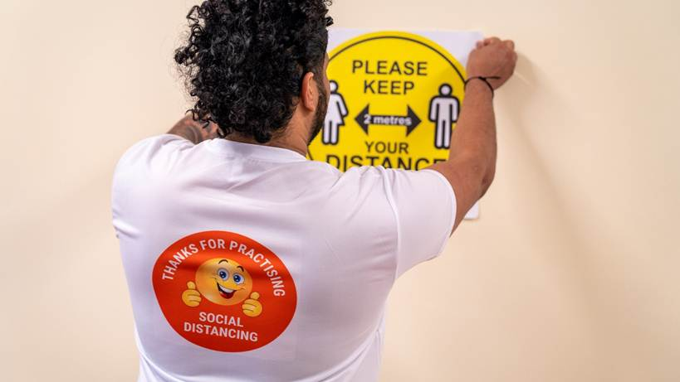

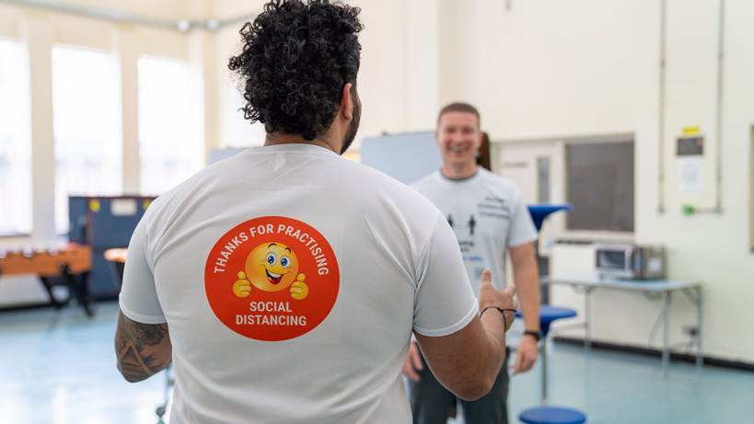

**Useful Resources:**



(With thanks to HMP Huntercombe for sharing the enclosed pictures and resources).

* **Target and work with those who find it hard to comply**.

Phil Copple recently wrote to Governors on the topic of co-operation with COVID-19 controls.

In particular ‘*Governors will want to be mindful of the unintended consequences that any sanctions may have in driving more risky behaviours or creating a sense of fear amongst colleagues – you will want to consider sanctions only where other interventions have failed. A proportionate and reasonable response to apparent breaches in behaviour will encourage staff to come forward as part of the contact tracing processes, tell us when they have COVID symptoms and take appropriate action in self-isolating where necessary.’*

**What the evidence tells us…**

* Understand why people are not complying by listening to their reasons, concerns and what barriers they might be facing, using the Five Minute Intervention skill of ‘Socratic questioning’.
* Use the Five Minute Intervention skill of ‘rolling with resistance’ to avoid arguing.
* Come up with a joint plan to improve adherence.
* Make sure any consequences are explained well, and implemented consistently, swiftly and fairly.

**The Evidence in practice…**

* The majority of staff have complied with the processes that have been put in place both in the workplace and in wider society, this has helped to make establishments more COVID-19 secure. We recognise that at times lapses of concentration can occur and these can result in a breach of rules, it is recommended that open conversations take place between employees and managers when this occurs to explore any issues in more detail and provide support where required.

If a pattern of behaviour is developing or a clear breach has occurred than managers can follow the **conduct & discipline policy** that is in place. It is recommended that a simple enquiry is undertaken prior to any formal investigation to ensure that there are no significant or underlying compassionate reasons for the breach or behaviour.

* + - * HMP Liverpool have introduced return to work interviews with the Governor for staff who are required to self-isolate after being identified as a close contact through the prison track and trace system. The purpose is to determine the reason why a member of staff has been required to isolate, and to allow the staff member to work with the Governor to ensure that the issue does not happen again.

These are intended to be constructive and positive and should not be used as a punitive measure. Ensuring that we understand why someone has been required to isolate and whether we can learn from this to prevent it happening again is aim. An interview template is provided below to guide establishments who may wish to replicate this approach.

 

* Where a prisoner fails to comply with COVID controls (determined nationally or locally), staff and establishments should first challenge this behaviour and instruct the prisoner to follow the COVID controls with a focus on the importance of reducing the spread of the virus.

If a prisoner repeatedly breaches COVID controls and further action is needed, it may be appropriate to charge a prisoner under PSI 05/2018 Prisoner Discipline Procedures (Adjudications).

The following three charges would be appropriate:

**PR 51 (23) / YOI R 55 (26) disobeys or fails to comply with any rule or regulation applying to him; PR 51 (22) / YOI R 55 (25) disobeys any lawful order**; or in more extreme circumstances where for example a prisoner is coughing deliberately to aggravate the situation **PR 51 (5), YOI R 55 (6) intentionally endangers the health or personal safety of others or, by his conduct, is reckless whether such health or personal safety is endangered** could be used. There must be clear communication to prisoners so they are aware of the expectations on them. Without this, adjudications are open to challenge and will negatively impact perceptions of fairness in the discipline system.

Each establishment now has a dedicated **Contact Tracing Lead (CTL)** in place to carry out contact tracing enquiries and to support staff in understanding COVID-19 controls and requirements. Establishments are encouraged to liaise with their CTL about methods to encourage staff to engage with the CTL on any concerns/queries.