Guidance:
Barbering and Hairdressing in Prisons during COVID-19.

Introduction

In the community, hairdressers and barbershops were permitted to reopen for services relating to cutting or treating hair from 04 July 2020, following the November 2020 restrictions and once more on 12 April 2021. GOV.UK guidance for close contact services has developed significantly over the months and Prisons are advised to keep up to date with the GOV.UK live updates in respect of close contact barbering and services. These updates and the full GOV.UK guidance can be found via the following link:

https://www.gov.uk/guidance/working-safely-during-coronavirus-covid-19/close-contact-services

Prisons will apply the GOV.UK guidance within each setting. This being whether the barbering service is part of a residential wing activity or part of a wider salon service in a designated environment.

Within prisons, barbershops and hairdressing salons are subject to opening as part of HMPPS notifications on activation of activities and workshops. Such shops are currently not designated as essential workshops. Prisoners will however be permitted to recommence cutting each other’s hair on their residential units, in line with the specific COVID-19 controls and as part of a residential EDM activity as agreed for activation with Gold bulletins and publications ( this is set for activation from 12 April 2021).

This guidance is to be adopted in line with the HMPPS notifications on restrictions and opening activities. These may change and as such Prisons will activate/de-activate this service in line with the HMPPS notifications and their own agreed level outcome.

Operational Guidance

Guidance Aspect | Description and HMPPS application
Cohorting and Regime Groups | Prisoners must only be allowed to cut hair for prisoners who are within their specific regime group. Prisoners who are symptomatic or confirmed for COVID-19 (via a LFD or PCR test) cannot be allowed to either receive a haircut, or give a haircut to any other prisoners. In both cases, prisoners must complete the specified self-isolation period prior to receiving or cutting the hair of others.
COVID-19 Symptoms | The service will request any person wishing to have a haircut will declare they have no COVID – 19 symptoms.  – Have you had the recent onset of a new continuous cough?  – Do you have a high temperature?  – Have you noticed a loss of, or change in, normal sense of taste or smell?  This should be carried out prior to arrival in any waiting areas (see appointments). Each service provider will also declare they have no symptoms prior to commencing work each day. A recorded of this should be retained.  Persons self-isolating as part of a COVID test or contact trace are not permitted to enter the hair service area.
At Risk and Vulnerable persons | Particular consideration should be given to any prisoners whom are providing the hair service to others. Prison healthcare should be contacted for further advice in relation to individual residents COVID-19 risk. An assessment will be undertaken locally as to any allocation of residents carrying out this work.  Any prisoners from the at risk group attending a haircut should be done separately in any environment, this should be arranged via the appointment system where residents can request this. This provision should also be applied to any residents exempt from wearing a face covering.
COVID-19 Workplace Risk Assessment | Prisons will undertake a COVID-19 Workplace risk assessment for the specific hair task being undertaken (i.e. – residential unit barbering/salon activity). This assessment will be consulted with all relevant persons connected with this activity. Where local trade unions may not be applicable Prisons should consult the assessment within Prisoner forum groups. Local trade unions will be consulted in any case.
EDM & LOP | The activity will be included within the relevant EDM. Prisons will complete a local operating procedure for the hair service being undertaken. The aspects within this guidance, and those contained within the GOV.UK guidance will form the basis for the LOP aspects.
Lateral Flow testing (LFD) | Regular testing of resident service providers is a further control each LOP should consider. This would identify positive cases in the activity and prevent onward infection. Each LOP should identify whether LFD is to be adopted and the frequency and arrangements of its application.  Coronavirus (COVID-19) workplace testing: guidance for private-sector employers and third-party healthcare providers - GOV.UK (www.gov.uk)
Social Distancing and appointments | An appointment system should be adopted to ensure social distancing is achieved during any waiting area. Any waiting area will be designed to ensure 2 metre distance is achieved so that persons are kept apart from each other.  Persons providing the barbering/hairdressing service to others will not be able to achieve a 2 metre distance. This is therefore achieved as a 1 metre + mitigation measure.
Environmental layout | Screens should be deployed to separate persons in waiting areas where 2 metres cannot be achieved. Screens/barriers should also be deployed to separate < 2 metre workstations where the service is being provided (multi use barbering/hairdressing salons). This will be recorded in the COVID-19 risk assessment. Equipment and tools must not be shared across workstations.  Provide any necessary signage in the area to direct persons as needed. This will include providing limits on the amounts of people able to be in a designated waiting area. This limit will be recorded in the risk assessment following consideration of the dimensions.
Personal Protective Equipment (PPE)/Face Coverings (non PPE) | The person undertaking the service will be provided and wear:  1. Face Mask (Surgical Mask FRSM IIR) – minimum requirement is a Type II Mask.  2. Visor or Goggles  The person receiving the service will be provided and wear:  - Face Covering  Face coverings will remain on during the waiting area and during the service being provided.  Surgical Masks to be changed every four hours, following a break, or if damaged during use  Pictorial Guidance and further information is provided on the donning and doffing of the PPE/Coverings.  Waste Provision – surgical masks will be disposed of via the clinical waste provision.  Non disposable Visors and Goggles to be sterilised after use via Titan Chlorine application. This will be undertaken in Prison staff presence.
Safety | Establishments must make an assessment to decide safe areas within residential areas where haircuts can take place. These areas must be well ventilated and where possible be observable by staff.  During COVID-19, Instructions are to be relayed to prisoners that only controlled and described barbering/hairdressing arrangements are to be allowed in prisons. Prisoners must not provide independent barbering service to other prisoners using their own equipment.
Hygiene and Cleaning | Prisoners must be informed of the need to maintain good hygiene procedures when cutting the hair of other prisoners. Haircutting tools such as clippers, scissors and combs must be cleaned by prisoners thoroughly prior to use, at the end of the session and in-between uses using General disinfectant procured barber products (such as barbicide). These must continue to be used in line with the existing safe systems. However, during COVID-19 cleaning procedures, direct spraying should not take place. Staff should monitor or supervise either immersion cleaning of equipment or application of the disinfectant onto cloths to wipe all the surface areas.  General disinfection of hard surface areas of chairs must also take place between each person. Prisoners cutting hair must wash their hands prior to the haircut and again afterwards. Prisoners receiving a haircut must be requested to wash their hands prior to having their hair cut and again after the process has finished.  Areas within the hair service area must be cleaned regularly and always at the start of each day. This aspect is included with the risk assessment process. In specific relation to close contact services, chairs, equipment and areas must be cleaned between uses. Hard surface chairs should be adopted as this will provide more appropriate ways to achieve cleaning via general purpose disinfection. Records of the cleaning will be retained in each activity area, this will be monitored by staff and retained in a safe central place each day.  In the event of decontamination of equipment following contact with a symptomatic or confirmed case. All equipment will be immediately withdrawn from use and Chlorine detergent based solutions will be used at a rate of 1000 ppm to decontaminate all areas of the equipment and area. Please refer to equipment guidance in respect of areas where electrical parts should not come into contact with fluids.
Ventilation | Ventilation is an important consideration during the process. Areas where waiting or hair service is being performed should provide adequate fresh air movement. Windows and internal doors should be opened to provide flow of air as a minimum.
Security | Where prisoners are using tools such as clippers to cut other prisoners hair, establishments must ensure that local procedures for the management and control of these tools is adhered to.
Noise | GOV.UK has provided guidance that noise and background noise should be kept to a minimum as to avoid shouting (as this has potential to increase transmissions). As such, no radio or music should be used.
Contact Trace and Records | For the purposes of potential test and trace, records of all prisoners having their hair cut must be retained. These records must be retained for a minimum of 21 days.  In the event a person whom received a barbering/hairdressing service becomes symptomatic following receiving a service the HMPPS contact tracing strategy must be applied:  Contact Tracing – Prisons Exceptional Regime & Service Delivery (hmppsintranet.org.uk)  Records of each cleaning cycle must also be recorded by the prisoner undertaking the haircuts. Staff will monitor these records as part of the issue of the equipment. Staff should also carry out spot checks to ensure the sterilisation between uses is being carried out effectively.

Please note that all document referred to here can be found on the following link:

https://hmppsintranet.org.uk/ersd-guidance/

GOV.UK guidance is found at the following link

https://www.gov.uk/guidance/working-safely-during-coronavirus-covid-19/close-contact-services

Further Information and Documents

How to don and doff a surgical mask:

NHS – COVID Symptoms and what to do:

https://www.nhs.uk/conditions/coronavirus-covid-19/symptoms/

Annex
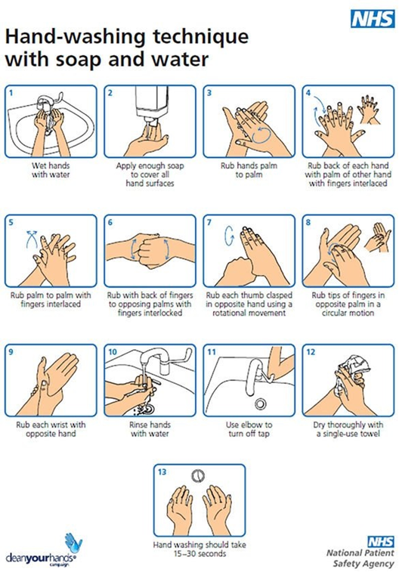

Wearing a face covering
A cloth face covering should cover your mouth and nose while allowing you to breathe comfortably. It can be as simple as a scarf or bandana that ties behind the head.
Wash your hands or use hand sanitiser before putting it on and after taking it off. Avoid touching your eyes, nose, or mouth at all times and store used face coverings in a plastic bag until you have an opportunity to wash them.
Do not touch the front of the face covering, or the part of the face covering that has been in contact with your mouth and nose. Once removed, make sure you clean any surfaces the face covering has touched.
You should wash a face covering regularly. It can go in with other laundry, using your normal detergent.
When wearing a face covering, take care to tuck away any loose ends.

