**16.03.21 Stage 3 Progression Recap**

Dear Executive Directors, Prison Group Directors and Directors/Governors,

Please see the below summary which is a brief reminder of the process for progression to Stage 3 for adult sites which is being shared in response to queries from establishments about the process in place. Please also see attached the briefing which was published on 01.03.21 and provides a more in depth summary of the agreed progression process to stage 3 for adult establishments.

The process for progression to Stage 3 of the national framework has 2 stages. This is displayed in a flowchart below.

**Stage 1: Establishment is placed on the Progression List.**

Progression List sites are decided upon by the Heatmap Panel which meets each Friday. Sites where the local COVID-19 data (including case data, community prevalence data, testing data and population vulnerability) suggests that progression to stage 3 may be appropriate are discussed and then progression list decisions are made. Sites are also able to apply to be exceptionally considered for progression via their PGD where the Governor/Director perceives that they are in a local position to proceed their regimes to Stage 3 or the local circumstances or risk picture may necessitate swifter progression to Stage 3.

The progression list decisions will be shared with PGDs and EDs immediately following the Heatmap panel on a Friday, and then these sites will also be updated on the Heatmap which is accessible via <https://hmppsintranet.org.uk/ersd-guidance/2020/09/28/heat-map-for-reverse-cohorting-requirements-to-review-regime/>. This information will also be shared in the Gold weekly update which is published via COVID-19 Gold and central comms on a Friday afternoon.

Being placed on the progression list means that a site can submit their Stage 3 reintroduction paperwork (Annex A in the attached briefing) – it does not mean automatic progression. This paperwork is a singular ‘checklist’ style document which establishments must complete to demonstrate that assurance work has been undertaken and that health partners, relevant stakeholders and local Trade Unions are satisfied that delivery of Stage 3 regimes is appropriate at that time or have been fully consulted. Establishments are not be required to re-submit any EDMs and will be able to revert to the Local Operating Procedures for Stage 3 they had in place prior to the January national restrictions, mindful of the additional restrictions set out in the attached briefing.

Establishments must share any revised LOPs with their stakeholders (including trade unions). A logical way to identify LOP changes is:

* 1. Consider the list of Winter Review EDM changes – which ones are relevant to your establishment
  2. Consider general infection prevention and control changes which your establishment has made since you were last at Stage 3 – put in suitable references to your LOPs (eg LFD for ROTLs)

Leave these changes highlighted in some way and share them with Trade Unions for them to see, and then confirm that they are content. Where there is not a local representative of a trade union at the establishment, contact details for regional reps are provided in the attached.

Finalised Checklist documents should be sent to: [HMPPSCOVID19@justice.gov.uk](mailto:HMPPSCOVID19@justice.gov.uk)

**Stage 2: Gold Regime Panel**

Following submission of the checklist documents to Gold, they will be presented by a representative from the ED’s office at the next panel meeting confirming all is in place to permit approval to progress to Stage 3.

As set out in the attached briefing, there are a number of additional regime restrictions currently in place at Stage 3. This means that currently, following progression to stage 3 there are still some regime elements restricted due to community guidelines. For example, **social visits** remain paused at Stage 3 due to the current travel restrictions. We will publish further guidance on when these will be re-introduced in due course. Establishments are able to begin planning for the re-introduction of these regime elements  and may wish to engage with their family services providers in that planning, but are asked not to publicise visit re-start dates or any other information until further information is shared from the centre.

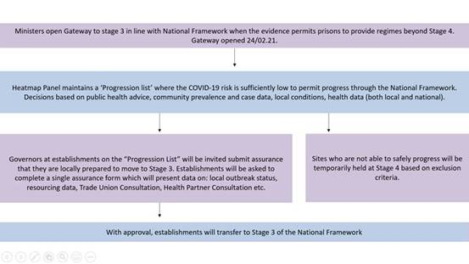

Please direct any further queries on this topic to [COVID19.Regimes&OpsGuidance@justice.gov.uk](mailto:COVID19.Regimes&OpsGuidance@justice.gov.uk).

