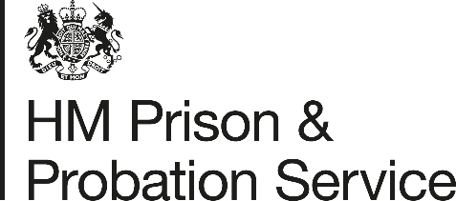

COVID-19 Face Protection Review – COVID-19 Gold Briefing to Staff

Following the emergence of new COVID-19 variants, inter-agency discussions with HMPPS prompted a review of the face protection being applied in prison and probation settings.
This review included advice from public health officials (PHE), liaison with the Department of Health and Social Care (DHSC) and input from the most recent scientific and authoritative reports undertaken by SAGE, into the application of control measures in light of the new variant of COVID-19 and the World Health Organisation report into the application of face protections. HMPPS Health & Safety colleagues also liaised with colleagues in other public sectors to compare responses. This included receipt of the Police PPE applications and a recently published infection control measures document from the NHS.
The overall combined messages from these sources of information were:
Face Coverings remain an effective measure in community settings.
Face Masks (FRSM – Fluid Resistant Surgical Mask ) remain an effective measure in close contact working environments (including with COVID-19 positive cases).
FFP Masks are only recommended for use during an aerosol generating procedure (these being usually found within a clinical setting).
Evidence did not support the addition of face visors to face protections where not already prescribed.
Social distancing remains a key general control in consideration of face protection measures.
The senior HMPPS board considered this review and has concluded there is no change to the current specification and application of face protections or prescribed COVID-19 PPE. A Government review of COVID-19 PPE is pending and this will follow the full SAGE report. HMPPS will continue to review face protection measures in liaison with PHE and DHSC.
COVID-19 Gold has recently released guidance to assist prisons during hospital escorts to COVID-19 wards. Where residents are working in similar or same close contact work as our staff the use of the FRSM will be extended to residents. This will not however extend to a wider application during outbreaks or tasks not being specified.
POA NEC have been in consultation with HMPPS throughout this process and have written joint communications asking staff to:
- Please follow all SOPs, wear PPE appropriately and follow any other measures that have been put in place. If you wear your FRSM correctly you will not normally have to self-isolate.

HMPPS Gold Command & HMPPS H&S Directorate, February 2021

