Recovery Regime Management
Plan (RRMP)
June 2020

Contents | Page
Introduction | 3
Communication Strategy | 4
Equality Analysis | 5
Exceptional Delivery Models | 5
Risk Assessments & Operating Procedures | 6
Resource Planning | 6
Operating Procedure Templates | 8

Introduction
In response to the threat of Covid-19, the Ministry of Justice (MoJ) and Her Majesty’s Prison and Probation Service (HMPPS) took decisive action to monitor, manage and mitigate the threat of large numbers of staff and prisoners becoming infected with COVID-19 and to reduce the likelihood of the infection spreading through the prison system.
This involved restricting regimes to implement social distancing, as set out in the Exceptional Regime Management Plan, limiting movement of prisoners between prisons, and starting a programme of work to compartmentalise the estate to isolate symptomatic prisoners, shield the vulnerable, quarantine new entrants and protect staff.
Similar to the lifting of restrictions in the community, the re-opening of prison regime will be guided by our 3 Core Objectives:
- Preserve Life: To continue to protect our staff, the public, and offenders in our care by minimising deaths and hospitalisations, ensuring continued access to healthcare, and protecting the NHS from explosive outbreaks.
- Maintain Security, stability and Safety in the broadest sense: To ensure the ongoing stability and safety of the estate, including risk to disorder, violence, suicide & self-harm levels, escapes, protecting the public, and sufficient staff confidence to deliver regimes and rehabilitative activities as intended.
- Provide Sufficient Capacity: Ensuring that we have enough space to receive from the courts and sufficient capacity to meet overall demand, as well as sufficient staffing and resource to run establishments.
Under the National Recovery Framework there will be a five stage model of different regime stages which will guide establishments from stage 5 (complete lockdown) back to stage 1 (prepare), which will be mirror ‘business as usual’ operation with no known infections of COVID-19, regimes operating without restrictions.
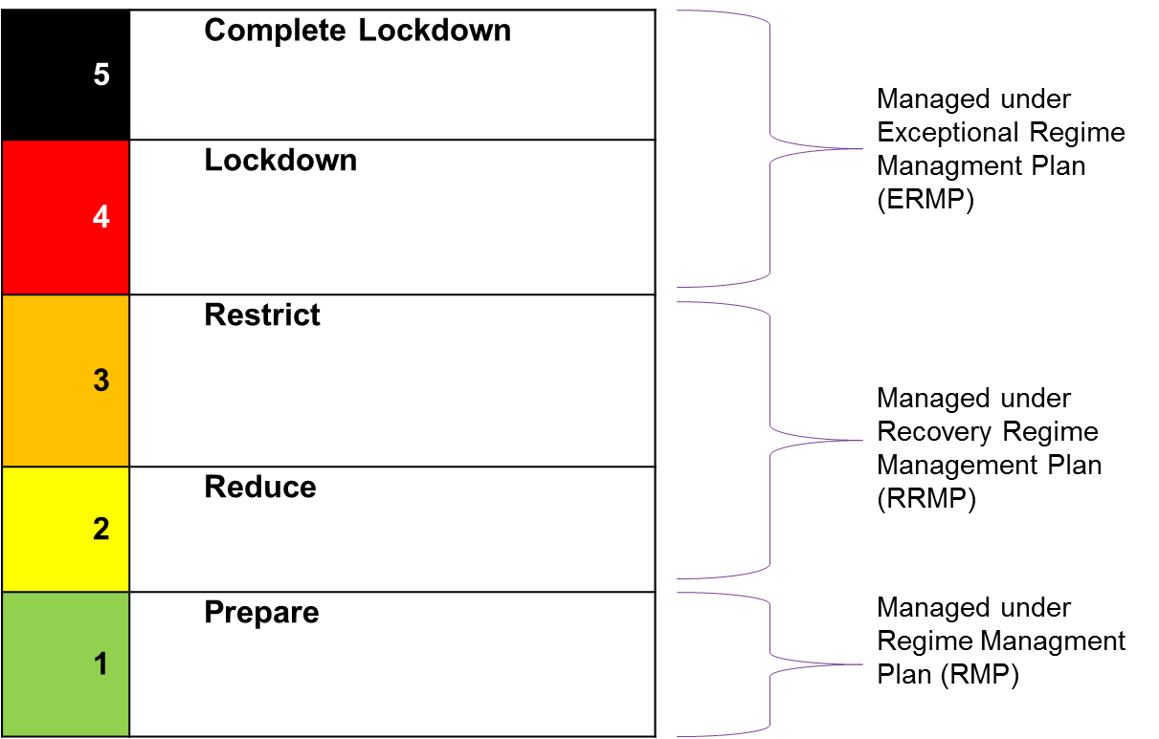
This guidance is intended to help support governors make decisions locally, within the National Framework, and identifies the areas of the regime that should be prioritised. It will ensure we have a rigorous, evidenced and data-driven basis for decisions and that resources are appropriately identified to support delivery of the regime. All regimes must comply with the Prison Act 1952, the Prison Rules 1999, YOI Rules 2000, the Human Rights Act 1998, the Health and Safety at Work Act and the wider legal framework.
Different prisons will be assessed as being ready for different Regime Stages, and may move in different directions over time. Progress will be incremental, particularly when transitioning to a lower stage; rather than an overnight adoption of all aspects of the relevant regime for that Stage, they will be fully realised over time. Prisons will move up or down the stages in response to local conditions such as an outbreak of infection in the prison or the community, or rates of staff absence. Regimes will be required to go straight back into (Stage 4) lockdown from lower stages where advised by Outbreak Control Teams or directed by HMPPS centrally.
Communication Strategy
As enablers for our objectives, we will need to ensure buy-in from staff, prisoners, trade unions, partners and external stakeholders, continue to make innovative use of technology, and work collaboratively with partners.
Communications plans will:
  - Explain HMPPS's approach to easing restrictions so that key audiences understand the approach and the considerations which must be addressed before any easing of the prison lockdown can safely happen.
  - Reassure the public and our stakeholders that HMPPS continues to respond and adapt to this pandemic, and is focused on restoring, rebuilding and regenerating as and when it is safe to do so.
  - Enable two-way engagement with our staff, service users, trade unions and wider stakeholders to ensure that HMPPS's recovery strategy is driven by their insight and we maintain their confidence and support.
  - Defuse tensions and pressure potentially triggered when the 'we are all in this together' narrative is less applicable, as prisons take different action at different times.

It is essential that recognised trade unions are meaningfully engaged and consulted in the design process. Recognised Trade Unions are working constructively and at pace (due to the unprecedented nature of this operational emergency) with HMPPS at a national level with consultation being delivered to shorter than normal timescales. Locally, it is important that this approach is mirrored and appropriate increased levels of facility time are allocated to allow for local recognised Trade Union branch officials (POA, PGA and NTUS (FDA, GMB, PCS, Prospect, Unite) trade unions) to have sufficient and meaningful input to the RRMP.

It is important to note that partner providers will need to be involved in plans for recovery, ensuring that both the operational planning and the planning for service providers lines up.

As part of the Communications Strategy, establishments should make a record of engagement with recognised Trade Unions, other staff groups including those not directly employed, NHS partners and Health Commissioners, prisoners, families and third sector.

Communication strategies developed in the YCS should reflect the different partnership arrangements, safeguarding authorities, and specific needs of children.

Equalities Analysis
Ensuring equality of access to all regime elements for all prisoners should be considered as part of the RRMP. Public Sector Equality Duty requires decision makers to have regard to the need to—(a) eliminate discrimination, (b) advance equality of opportunity and (c) foster good relations between persons with different protected characteristics.
Establishments must complete an Equality Analysis and feed this back into the decision making process around how to implement regime recovery. A template Equalities Analysis has been included below. Details on the completion and subsequent use of the Equalities Analysis are included within.

Exceptional Delivery Models
Exceptional Delivery Models (EDMs) will be published for individual areas of the prison regime, covering how to deliver aspects of the regime at every stage. Each will be a brief guide on the high-level principles that must be incorporated into a local plan for each element of regime being reinstated. It is essential that the initial/interim stage of recovery is not seen as a reversal of measures put in place to this point, or that pre-existing procedures are automatically reinstated when there may be steps to go through to reach this point safely or possible changes in the method of delivery going forwards. The specification will ensure establishments are clear on expectations from the outset. EDMs will cover all elements of regime from reinstating limited on wing activity to social visits. These will be developed in consultation with Public Health England / Wales advice to ensure that prison regimes are established in a way that ensures the ongoing safety of staff and prisoners.
As will be set out in the EDMs, some activity will look very different depending on the Regime Stage the prison is operating at – for example in terms of the maximum number of people attending a visit, or the social distancing requirements. Some activity will only take place once the prison has progressed to a certain Stage. This will also vary depending on the type of establishment, and reflect local priorities e.g. the importance and statutory obligation to provide education for children in the YCS estate.
Approved by SILVER
(submitted by Bronze –Governor proposed RMP)
There is local discretion for Governors, in consultation with the relevant unions and in accordance with the relevant element of the EDM, to determine the detail of how the delivery models can best be implemented locally. This will include the expected timeframe and order in which these aspects are turned on as the prison transitions to the new Stage. It may take some time to fully achieve all regime aspects of a given Stage given the need to test new ways of working, but broadly we expect establishments to be operating the full regime applicable to that stage within [4-6 weeks] of adopting it.
The full suite of EDM’s is available on the Operational Guidance platform here:
http://hmppsintranet.org.uk/except/

Risk Assessments & Operating Procedures
All Government sectors are required to provide “Working Safely” Guidance for their staff. Below is the “HMPPS Working Safely during COVID-19 in Prisons” guide which includes the mandatory Risk Assessment template to be used for all risk assessments being completed around elements of regime throughout recovery.
Existing risk assessments and safe systems of work underpin our operating practices. Any new practice requires assessment as normal. However, it is essential that as part of the Recovery Regime Management Plan, each element of regime is risk assessed for being safe under COVID-19 conditions using this template. Once the risks have been identified, this should inform the Operating Procedures which will make up the Regime Recovery Plan. Operating Procedures should actively mitigate the risks identified within the Risk Assessment and provide staff with clear and safe instructions on how to deliver the regime. The recommended template for Operating Procedures is provided at the end of this guidance and reflects current RMP policy templates.

Resource Planning
As part of the RRMP design, it is essential that your establishment is clear on the resource required to deliver the proposed recovery regime in a safe manner. The design of a temporary core day and a review of the required resource to deliver this should be carried out to inform planning.
As with normal Regime Management Planning, we should deliver as much regime as it is safe to and no more regime than the resource safely allows. As such, every establishment will establish (or re-establish where this was already in place) a Regime and Resource Planning meeting recommended under PSI2017/07. Guidance for the recommended process is attached below:
In order to be deemed ready for recovery through the Readiness Assessment, establishments must be able to show that their forecasted staffing can sustain the level of regime being proposed. This will be accomplished by providing a two week forecast from the Regime and Resource Planning meeting and an 8 week view of Workforce Planning. As part of this, establishments are also required to include a complete Resource Calculator (attached) in consultation with local recognised Trade Unions and Staff Associations. Resource should be calculated to include EDM requirements as well as any new work such as new temporary accommodation or additional video courts. This will be moderated by the Prison Group Director and Executive Director through the Readiness Assessment.
Temporary MSL’s will need to be established and, in line with Bulletin 8, must deliver safety, security and control. These MSL’s may vary from the established MSLs due to the differing challenges posed by COVID-19 and infection control measures that need to be maintained. Consultation with the POA when establishing MSL’s is a requirement under Bulletin 8.
Regime and Resource Planning meetings should continue to determine the level of regime that is safe to deliver on a week by week basis and, as in business as usual circumstances, decisions will need to be made about what can and can’t be run based on available resources. These meetings should be used to communicate and co-ordinate with delivery partners to ensure they are in place to support recovery. Establishments must report to their respective regional Silver commander where available resource is forecasted to be unable to deliver the MSL and normal resource planning avenues (e.g. PP, volunteers, TOIL) have been exhausted.
Minimum Alarm Response must still be identified. Those staff identified as alarm bell response must be able to respond to incidents without leaving their work area unable to work to safe operating procedures.

Unit Name (s) |  |  |  |  | Overview
Function
Capacity
Category
Layout
Regime Stage | Staffing Requirement |  | Max Prisoner No’s Unlocked | Work that can be delivered  (to note this work list will not be exhaustive) |  | Specific Controls  (including Social Distancing and infection control measures)
3
Additional Notes
Operating Procedure Templates

Activity Space Name |  |  |  |  | Overview
Activity
Capacity
Layout
Regime Stage | Staffing Requirement |  | Max Prisoner No’s Unlocked | Work that can be delivered  (to note this work list will not be exhaustive) |  | Specific Controls
3
Additional Notes

(intentionally blank)

